Name:
Date:

ADVENTURE ENGINEERING- “Lost in the Amazon” LESSON 1: The Crash Scene

Activity 1: “Assess the Situation”

The pilot awakens to find you and your teammates gathered around him. He has a bandage on his head and tries to talk.
“There is a map… in the cockpit… the monitor… look at the monitor,” the pilot manages to say before he faints. He is too weak to stay conscious very long but you go to the cockpit and find the map and the monitor which you can use to find your location.
You and your teammates look at the map. “Where are we? It all looks like forest to me,” says someone.
Maria, who actually paid attention in geography class, speaks up. “Well, we can see our latitude and longitude on the monitor. It shows us exactly where we are by using the Global Positioning System satellites in the sky. Now we can figure out where we are on the map, where we want to go and how far away it is!” Everyone looks at the map hoping the nearest city isn’t very far away.

Procedure:

On the next page is a map of the Amazon around the area that you have crashed. Notice the scale, the key, and the latitude and longitude markings on the map. Using the latitude and longitude values given in the box below, mark an X on the spot where you have crashed. (Hint: Trace along the latitude and longitude lines to help you find the exact crash location.)

Latitude: 2 ½° S Longitude: 60° W

1. To be rescued, do you want to go to a (Hint: there could be more than one answer):

City?
Village?
Airport?

2. Use the legend on the map to help you decide where you want to go and mark the spot on the map with an O.
Record the name of where you want to go

3. Add the X and the O symbols to the legend. Then, use a ruler to draw a dotted line
between the X and the O on your map.

4. Measure the length of the dotted line in inches and record it below.

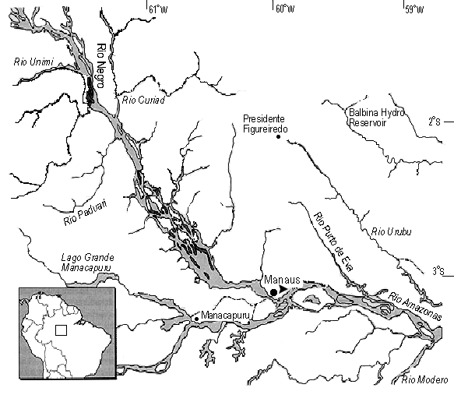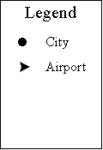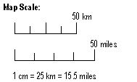5. Convert the length from inches to miles (Hint: you’ll want to use the conversion factor of
5280 ft/mile) and record your answer below.

6. As a class, vote on a route that you all will follow. If the route chosen by the class is different than the one you chose earlier, draw the new route on your map in a solid line. Repeat steps #4 and #5 for the solid line and record your results below.

Length of solid line:

Distance in miles:

Estimating the Time of Travel:

Now that you know how far you will be traveling, you will need to estimate the time it will take to reach your destination. Use the tables below to help you plan for your journey.

Table 1: Walking Speeds

Weight carried |  | Walking Speed
0 – 23 lb. |  | 3 mph
24 – 46 lb. |  | 2 mph
47 – 70 lb. |  | 1 1/2 mph

1. Use Table 1 to find your walking speed. Note that the speed you can travel depends on how much you are carrying. For now, assume you are carrying 45 lb.

What is your walking speed?

Table 2: Speed and Distance

Speed |  | 3 mph |  | 2 mph |  | 1.5 mph
Normal day’s walk |  | 24 miles |  | 16 miles |  | 12 miles

2. Use Table 2 to find out how many miles you can walk in an entire day. This chart assumes you will walk for about 8 hours. Match your walking speed from Question 1 to find your total miles per day.

How far can you normally walk in a day?

Table 3: Terrain Adjustments

Terrain Type Speed modifier

Plains Multiply miles walked by 1 (x 1)

Swamp Divide miles walked by 2 (÷2)

Forest Divide miles walked by 2 (÷ 2)

Mountains Divide miles walked by 4 (÷ 4)

River Multiply miles walked by 2 (x 2)

3. You can’t walk as fast through the mountains as you can over a normal road. Use Table
3 on the previous page to find your speed modifier if you walk through the forest.

What is your speed modifier?
What if you walked through the swamp instead? Would your speed be faster, slower or the same than if you walked in the forest? Why?

4. Using the number of miles walked in a day (from Question 2), find the distance you can travel in a day by following the directions under “speed modifier”.

How far can you travel in the forest in a day? How far can you travel on the river in a day?

5. Using the Tables 1, 2, and 3, estimate how long it will take you to reach your destination. Calculate the speed and time for each part of the trip in the box provided below (i.e. for each type of terrain.) Show your work.

Type of Terrain | Speed | Time

Total Time:

