Arduino Overview
An Arduino is a microcontroller—a tiny simple computer. It is very useful for physical computing, the process by which computers are able to interact with their surroundings via sensors and actuators. It is so versatile, that it is very frequently used in do-it-yourself projects as well as by scientists and engineers.
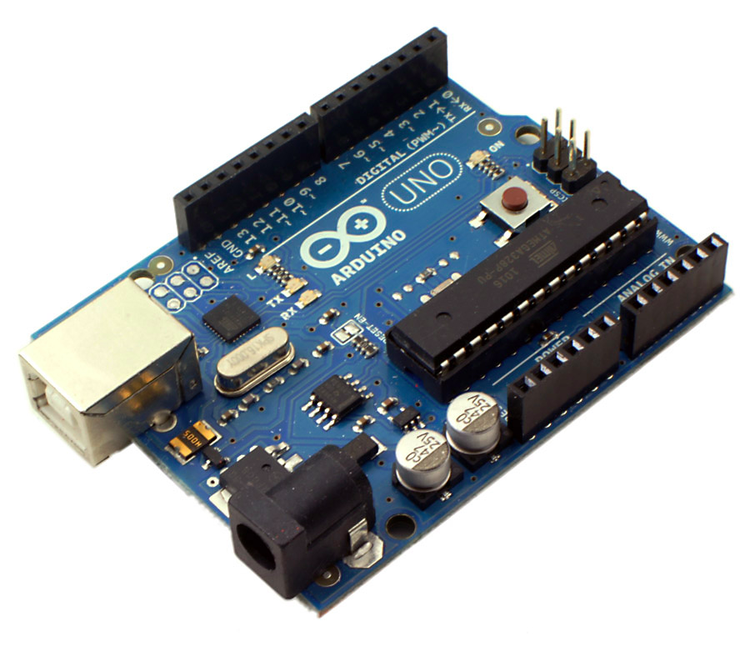
digital input/output (I/O) pins
reset button

analog input (I/O) pins

USB port/jack

power pins
(including ground “0V”)
port for 9V power adaptor

Some notes about the way Arduinos work:
- Once a program is uploaded to the board, it will run forever. Even if power is cut to the Arduino, the program is still stored in the memory of the Arduino and will begin executing once power is returned.
- The Arduino is usually powered by the computer using a USB cable. It can also be powered using a 9V power adaptor or a 9V battery.
- The Arduino can be used like a battery to power simple devices (like LEDs) as well as receive signals from devices (like photo resistors). This is done by connecting them to the I/O pins.
- The digital pins can be used as inputs (for sensors) or outputs (for actuators). However, they are limited in that they only have two settings: “HIGH” (or 5V) and “LOW” (or 0V).*
- The analog pins are used as inputs only (most sensors will be connected to this type of pin). They can measure a range of values between 0V and 5V.
- All three ground pins are identical.
- NEVER allow a direct connection (or short circuit) between any power pin and ground. This permanently damages the Arduino board and could potentially harm you.
*Using pulse-width modulation (PWM), voltages between 0V and 5V can be simulated.

