Post-Activity Quiz
- Is a plastic bottle organic waste? Check yes or no: Yes No
Why?

- Is compost considered organic waste OR a product that we can use to grow plants?

- What is a pesticide?

- Why do many farmers wear masks when they are applying pesticides?

- Explain the greenhouse effect.

- Two farmers needed to get rid of the undesired plants (weeds) in the soil in two different plots where they intend to plant tomatoes. The first farmer had 90 weeds on his plot. He treated the plot using soil biosolarization. After 10 days, 8 weeds were alive. The other farmer applied a pesticide eliminating 60% of the weeds.
- Estimate the percentage of weeds that was eliminated by soil biosolarization.

- Which weed-eliminating method was more effective?

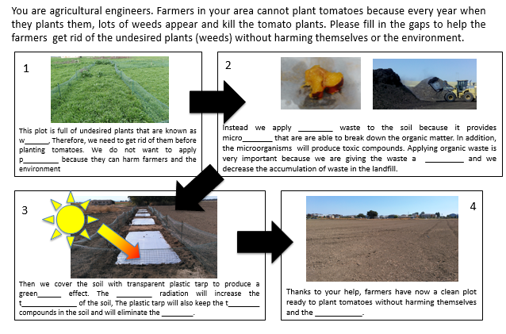
7.

