Magnetic Fluids Worksheet

Background

Materials can react quite differently to the presence of an external magnetic field. Most materials fall into three categories by their response to externally applied magnetic fields: paramagnetic, diamagnetic and ferromagnetic. Their magnetic responses differ greatly in strength. Among these categories, ferromagnetic materials exhibit the largest magnetic permeability. As the name suggests, ferrofluids are composed of ferromagnetic particles, surfactant and carrier fluid. Ferromagnetic particles are used because of their large magnetic permeability compared to other classifications of magnets. Essentially, the resultant magnetic field is orders of magnitude larger than the induced magnetic field, which becomes important when manipulating ferrofluids under moderate and controlled magnetic fields.

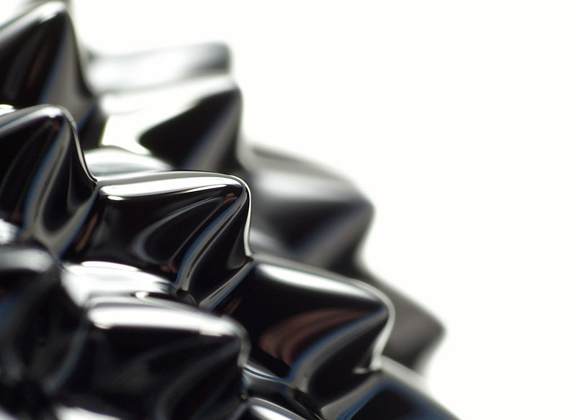
Acting as a material science engineer, create your own ferrofluid. Your challenge: To make a magnetic ink that you can write with and test to see if it works. Be an exceptional observer and document everything you see. Use your observation skills and newly found knowledge of ferrofluids to complete this worksheet. Good luck!

Materials
- large test tube with a stopper or lid
- (if using a stopper) duct or electrical tape
- 1 rare earth magnet
- stir rod
- 1 stylus or pen
- blank sheet of paper
- appropriate glass wear (such as a 200 ml beaker)
- 50 ml MICR toner
- 30 ml vegetable oil

Part 1: Let’s make a ferrofluid

Ferrofluid fabrication procedure:
- Pour 50 ml MICR toner into a 200 ml beaker.
- Pour 30 ml vegetable oil into the 200 ml beaker.
- Stir the mixture until it has a light, smooth texture.
- Carefully, pour fluid into an empty test tube and seal with a lid or stopper.
- Make sure the stopper is securely in place. DO NOT spill your ferrofluid.

Part 2: What did you really use to make your ferrofluid?

The diagram below depicts what is going on in your test tube. Although you cannot see the particles, they are there. Fill in the three spaces in the magnified drawing to identify the components. Below the diagram, describe the purpose of each labeled component.
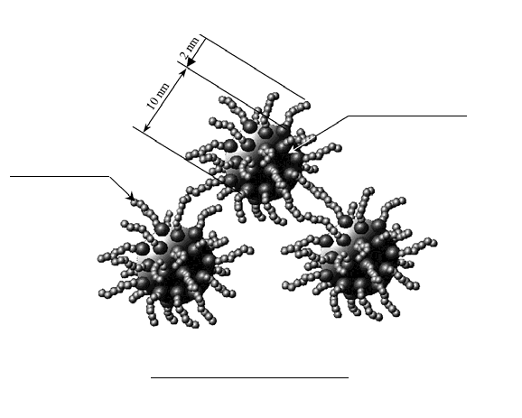
2.
3.
1.
Component 1:
_____________________________________________________________________________________
Component 2:
_____________________________________________________________________________________
Component 3:
_____________________________________________________________________________________

Part 3: Magnetic Ink

Magnetic ink procedure:
- Remove the stopper from the test tube. Make sure not to spill any fluid.
- Dip a stylus (or pen) into the test tube and allow the fluid to seep onto its tip.
- Remove stylus and begin writing on a blank piece of paper.
- Allow the paper to dry for 10 minutes.
- While it is drying, complete Part 4.
- Once dry, test your ink with the permanent magnet, and then complete Part 3

Questions
- Did your magnetic ink work? Explain why or why it didn’t work. Hint: think of how the particles might be aligned prior to an induced magnetic field.

- How might this ink be used in everyday life?
List at least one application, with 1-2 sentence explanations.

Part 4: Fun with Ferrofluids

Fun with ferrofluids procedure:
- Place the stopper back on the test tube top, if not already on it.
- Using tape, securely fasten the stopper to the test tube.
- Feel free to move the liquid around and play with the permanent magnet.

Questions
- In the boxes below, document your observations of the ferrofluid when exposed to the external magnet and when not exposed to the magnet. Use drawings and descriptions.

without magnetic field
with magnetic field

- How would you describe the ferrofluid when it is NOT exposed to an external magnet?

- How would you describe the ferrofluid when it is exposed to an external magnet?
Explain how the physical properties of the fluid changed.

- Where might you use this type of technology or property manipulation?
Name three applications with a 1-2 sentence explanation each.

