Pre-Lesson Worksheet
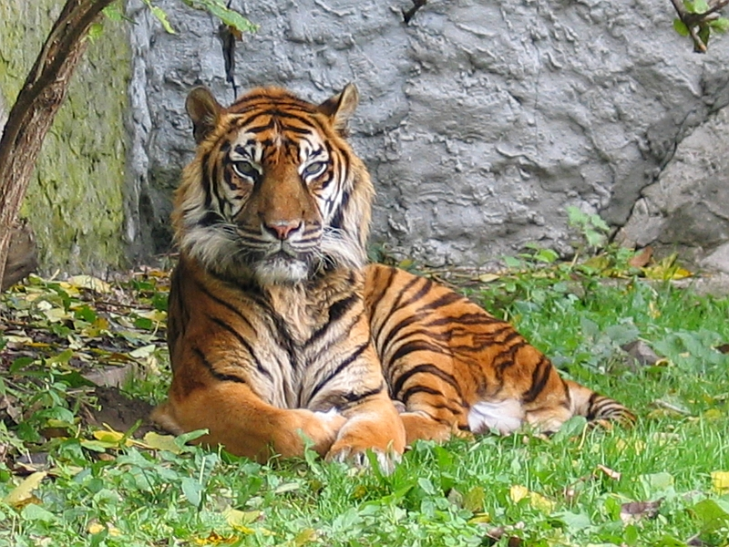
The questions below pertain to the tiger shown in this photograph.

Image source: 2004 Monika Betley, Wikimedia Commons
http://commons.wikimedia.org/wiki/File:Panthera_tigris_sumatran_subspecies.jpg

- What determines the color of the tiger’s coat?

- If the DNA sequence were to change, what would this be called?

- Explain how a mutation could cause this tiger to have a white coat instead of an orange coat.

